

[www.kletech.ac.in](http://www.kletech.ac.in)

**ONLINE COURIER MANAGEMENT SYSTEM**

BY TEAM-07

|  |  |
| --- | --- |
| Names | USN |
| Suprita R Uppar | 01FE19BCS180 |
| Chandana S | 01FE19BCS187 |
| Neeta Shinde | 01FE19BCS195 |

**Course Code:15ECSC208**

**Course Name: DBMS**

**Semester: 4**

**CONTENT**

|  |  |
| --- | --- |
| **S.No** | **TOPIC** |
| **1** | **Problem Description** |
| **2** | **Methodology** |
| **3** | **Architecture Design** |
| **4** | **Database Design** |
| **5** | **Normalisation and Schema** |

* **Problem Description:**

Online courier service management system is a project which aims in developing online system to enable courier service.

This project has features like user login, courier delivery, payment. Admin can login and can monitor the whole system. The courier service is one of the solutions to the problem to send some things to any person in the world within time. The courier company has number of branches spread over the country.

So, when person wants to send things then he has to contact at nearest courier service branch. The courier service work as destination office or source office. The source office branch receives the order means consignments and sends it to the destination courier branch. The company has certain rules according to the weight.

In our course project the admin has only the authority to change or manages the managers, delivery and courier to change and update and perform the basic operations on the database. And he overviews and manages the courier system. But manager doesn’t have that authority but he has authority to manages the customer and amount to be paid by them.

* **METHODOLOGY**
* Create an interface that interacts with the database.
* Admin has an authority over manager, delivery and courier to modify details and manage.
* Manager has an authority over delivery, courier and bill to manage.
* Admin, Manager, Customer has to login to perform courier transferring.
* Customer can order his courier. And he pays bill for the courier.
* The admin has more authority to modify the database but its not the same with managers.
* The operations to the customers are only to check the courier delivery and to the pay the amount prescribed for the courier based on the weight.
* To perform all the operations mentioned we use SQL database and others.
* The main aim of the project is to apply the knowledge of SQL taught under DBMS class in real life project by creating online courier management system that keeps the recording of login details of customer, admin and managers and how the management of courier and delivery happens to the customers.

**Entity and Their Relationships:**

**1 LOGINS**

* Login by admin
* Login by customer
* Login by manager

**2 ADMIN MANAGEMENT**

* Admin manages manager
* Admin manages customer
* Admin manages courier
* Admin manages delivery

**3 MANAGER MANAGEMENT**

* Manager manages courier
* Manager manages Customer
* Manager manages Bill
* Manager manages delivery

**4 CUSTOMER SERVICES**

* Customer books Courier
* Customer pays Bill

**Functional requirements:**

**Operations that can be performed on back end:**

1. Create the table of all entity with attributes.
2. Insert the respective values into the created tables using insert command.
3. Add the primary key and foreign key into tables created.
4. If we want to delete the data, we use delete command
5. To edit the values in the table we use alter command.
6. Calculate the amount to be paid by the customer for the delivery of the courier.

**Operations that can be performed on front end:**

1. Provided the customer to login to his account to check the delivery of courier.
2. Provided the admin to login and he manages over delivery, manager and he can oversee the delivery and courier details and he can modify the details.
3. Provided the manager to login into his account and he is made to oversee the delivery, courier details and he can modify the details.
4. The admin and manager can see the couriers placed and delivered to customers.

* **Architecture Design:**

**ER-DIAGRAM**

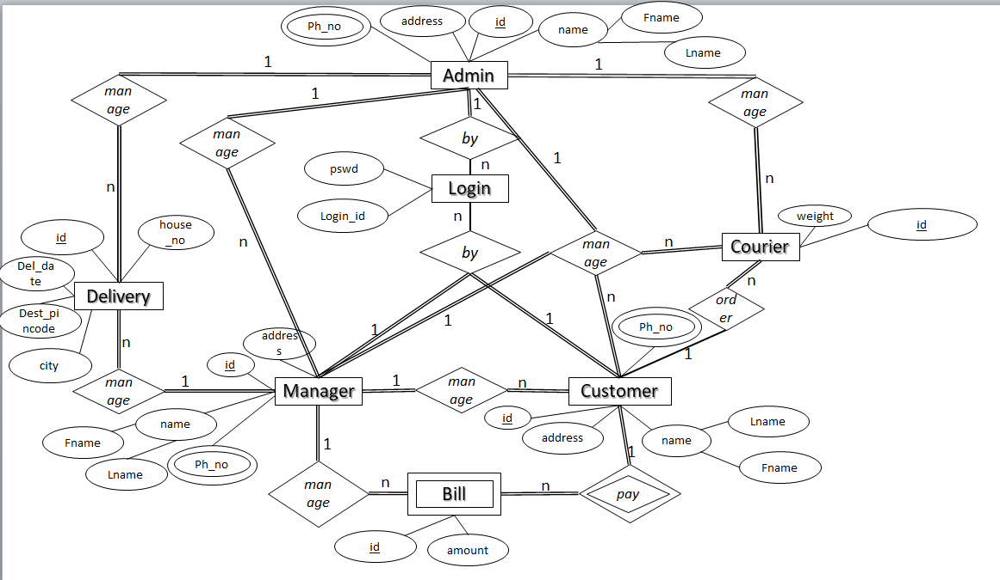

* **DATABASE DESIGN**

**Entities and their attributes:**

**Login entity:** **Strong Entity**

**Attribute data type**

* login_id varchar(20) -Primary key
* pswd char(10)

**Admin entity:** **Strong Entity**

**Attribute data type**

* Id varchar(15) -Primary key
* Fname varchar(10)
* Lname varchar(15)
* ph_no int(10)
* address varchar(15)

**Manager entity:** **Strong Entity**

**Attributes data type**

* id varchar(15) -Primary key
* Fname varchar(10)
* Lname varchar(10)
* ph_no int(10)
* address varchar(15)

**Customer entity:** **Strong Entity**

**Attributes data type**

* Fname varchar(10)
* Lname varchar(10)
* address varchar(15)
* ph_no int(10)
* id varchar(15) -Primary key

**Delivery entity: Strong Entity**

**Attributes data type**

* id varchar(15) -Primary key
* Del_date date
* Del_address varchar(15)

**Courier entity: Strong Entity**

**Attributes data type**

* Id varchar(15) -Primary key
* Weight float
* dest_pincode int

**Bill entity :** **Weak Entity**

**Attributes data type**

* id varchar(15) -Primary key
* amount float

**The ER Diagram is mapped to Relational Schema as follows:**

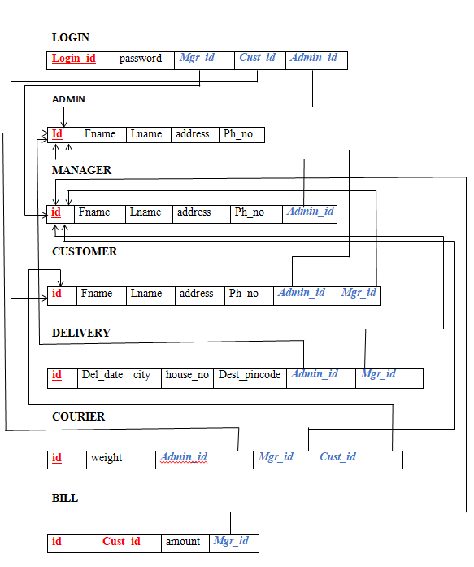

* **NORMALISATION:**

1. **Applying first normal form:**

**Customer**: In customer entity, Ph_no attribute is there which is a multivalued. So we can apply 1NF and create a new table called Cust_Phno

Customer:

|  |  |  |  |  |  |
| --- | --- | --- | --- | --- | --- |
| id | Fname | Lname | address | Admin_id | Mgr_id |

Cust_Phno:

|  |  |
| --- | --- |
| Cust_id | Ph_no |

**Admin:** In Admin entity, Ph_no attribute is there which is a multivalued. So we can apply 1NF and create a new table called Admin_Phno

Admin:

|  |  |  |  |
| --- | --- | --- | --- |
| id | Fname | Lname | address |

Admin_Phno:

|  |  |
| --- | --- |
| Admin_id | Ph_no |

**Manager:** In Manager entity, Ph_no attribute is there which is a multivalued. So we can apply 1NF and create a new table called Mgr_Phno

Manager:

|  |  |  |  |  |
| --- | --- | --- | --- | --- |
| id | Fname | Lname | address | Admin_id |

Mgr_Phno**:**

|  |  |
| --- | --- |
| Mgr_id | Ph_no |

1. **2nd Normal Form:**

Applying second normal form

As the first normal form obtained is already fully functionally dependent with respect to all relations, there is no need to apply 2NF.

The above normalization is already done with second normalization.

1. **3rd Normal Form:**

Applying third normal form

For,

Delivery entity the city and destination address with id and the three attributes have the transitive dependency.

i.e.

delivery_id 🡪 Dest_address

Dest_address 🡪 city

here delivery depends on the state where it should be parcelled. And the city is in state. So, to deliver the courier the city should be known and the state where it is in the map could be identified on state. So, to deliver the courier they are interrelated.

Delivery:

|  |  |  |  |  |  |  |
| --- | --- | --- | --- | --- | --- | --- |
| id | Del_date | Dest_pincode | Admin_id | Mgr_id | city | house_no |

Delivery_place:

|  |  |  |
| --- | --- | --- |
| Dest_pincode | city | house_no |

* **FINAL RELATIONAL SCHEMA AFTER NORMALISATION:**

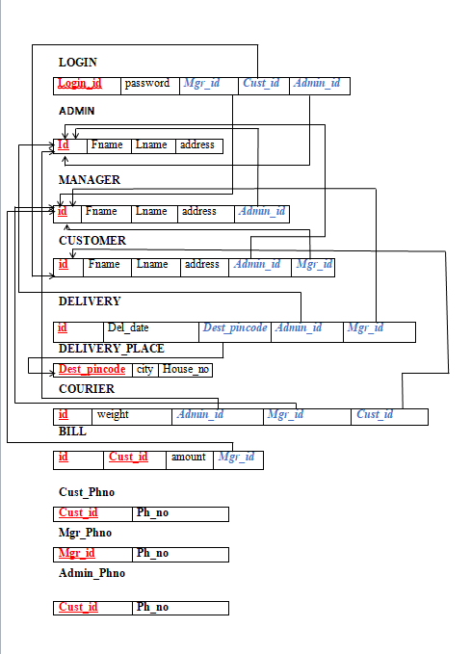

**IMPLEMENTATION:**

drop table Admin cascade constraints;

drop table Manager cascade constraints;

drop table Customer cascade constraints;

drop table Login cascade constraints;

drop table Delivery cascade constraints;

drop table Delivery_Place cascade constraints;

drop table Courier cascade constraints;

drop table Bill cascade constraints;

drop table Cust_Phno cascade constraints;

drop table Mgr_phno cascade constraints;

drop table Admin_Phno cascade constraints;

create table Admin

(

  id varchar2(20) primary key,

  Fname varchar2(20),

  Lname varchar2(20),

  Address varchar2(20)

);

create table Manager

(

  id varchar2(20) primary key,

  Fname varchar2(20),

  Lname varchar2(20),

  address varchar2(20),

  Admin_id varchar2(20),

  foreign key(Admin_id) references Admin(id)

);

create table Customer

(

  id varchar2(20) primary key,

  Fname varchar2(20),

  Lname varchar2(20),

  address varchar2(30),

  Admin_id varchar2(20),

  Mgr_id varchar2(20),

  foreign key(Admin_id) references Admin(id),

  foreign key(Mgr_id) references Manager(id)

);

create table Login

(

  Loginid varchar2(20) primary key,

  password varchar2(20),

  Mgr_id varchar2(20),

  Cust_id varchar2(20),

  Admin_id varchar2(20),

  foreign key (Mgr_id) references Manager(id),

  foreign key (Cust_id) references Customer(id),

  foreign key (Admin_id) references Admin(id)

);

create table Delivery

(

  id varchar2(20) primary key,

  Del_date date,

  Admin_id varchar2(20),

  Mgr_id varchar2(20),

  foreign key(Admin_id) references Admin(id),

  foreign key(Mgr_id) references Manager(id)

);

create table Delivery_Place

(

  House_no int primary key,

  city varchar2(30),

  Dest_pincode int,

  Del_id varchar2(20),

  foreign key(Del_id) references Delivery(id)

);

create table Courier

(

  id varchar2(20) primary key,

  weight_in_grams float,

  Admin_id varchar2(20),

  Mgr_id varchar2(20),

  Cust_id varchar2(20),

  foreign key (Admin_id) references Admin(id),

  foreign key (Mgr_id) references Manager(id),

  foreign key (Cust_id) references Customer(id)

);

create table Bill

(

  id varchar2(20),

  Cust_id varchar2(20),

  amount float,

  Mgr_id varchar2(20),

  foreign key(Mgr_id) references Manager(id),

  foreign key(Cust_id) references Customer(id),

  primary key(id,Cust_id)

);

create table Admin_Phno

(

  Admin_id varchar2(20),

  Phno varchar2(20),

  foreign key(Admin_id) references Admin(id)

);

create table Mgr_Phno

(

  Mgr_id varchar2(20),

  Phno varchar2(20),

  foreign key(Mgr_id) references Manager (id)

);

create table Cust_Phno

(

  Cust_id varchar2(20),

  Phno varchar2(20),

  foreign key(Cust_id) references Customer (id)

);

insert into Admin values('A200','Sucheta','Mehta','Mumbai');

insert into Manager values('Mg001','Harshad','Nayak','hubli','A200');

insert into Manager values('Mg002','Uma','Pawar','Bengaluru','A200');

insert into Manager values('Mg003','John','Geller','Mysore','A200');

insert into Manager values('Mg004','Ramesh','Nayak','Dharwad','A200');

insert into Manager values('Mg005','Ram','Patil','Hubli','A200');

insert into Manager values('Mg006','Kavana','Patil','Dharwad','A200');

insert into Manager values('Mg007','Sania','Vasishta','Bengaluru','A200');

insert into Manager values('Mg008','Michel','Green','Mysore','A200');

insert into Manager values('Mg009','Sham','Nayak','Mysore','A200');

insert into Manager values('Mg010','Geeta','Patil','Hubli','A200');

insert into Customer values('C321','Shiva','Kulkarni','#8 vidyanagar hubli','A200','Mg001');

insert into Customer values('C322','Pratiksha','Deshpande','#23 Malleshwaram Bengaluru','A200','Mg002');

insert into Customer values('C323','Pratyusha','Patil','#56 Ganesh Nagar Mysore','A200','Mg003');

insert into Customer values('C324','Sangeeta','Joshi','#58 vidyanagr Dharwad','A200','Mg004');

insert into Customer values('C325','Yamini','Parmar','#78 Unkal Road hubli','A200','Mg005');

insert into Customer values('C326','Sahana','Tiwari','#12 Maratha colony Dharwad','A200','Mg006');

insert into Customer values('C327','Arpita','Talpade','#89 VijayNagar Bengaluru','A200','Mg007');

insert into Customer values('C328','Sachin','Deshmukh','#123 hospete mysore','A200','Mg008');

insert into Customer values('C329','Shyam','Vasishta','#71 Gokul Road Mysore','A200','Mg009');

insert into Customer values('C330','Santosh','Kulkarni','#98 vidyanagar Hubli','A200','Mg010');

insert into Login values('A2000@gmail.com','abc123*','','','A200');

insert into Login values('Mg001@gmail.com','ghty45#','Mg001','','');

insert into Login values('Mg002@gmail.com','jkyu9*','Mg002','','');

insert into Login values('Mg003@gmail.com','ghty56er','Mg003','','');

insert into Login values('Mg004@gmail.com','dfGtrr5','Mg004','','');

insert into Login values('Mg005@gmail.com','hjyuiro*','Mg005','','');

insert into Login values('Mg006@gmail.com','ui89ty','Mg006','','');

insert into Login values('Mg007@gmail.com','Hy56RE','Mg007','','');

insert into Login values('Mg008@gmail.com','KL98Vb','Mg008','','');

insert into Login values('Mg009@gmail.com','IO98sd','Mg009','','');

insert into Login values('Mg010@gmail.com','nm67Gh','Mg010','','');

insert into Login values('C321@gmail.com','yu89Sd','','C321','');

insert into Login values('C322@gmail.com','Qw34Er','','C322','');

insert into Login values('C323@gmail.com','MnVcd4#','','C323','');

insert into Login values('C324@gmail.com','Sgh67ty','','C324','');

insert into Login values('C325@gmail.com','Kl239hd','','C325','');

insert into Login values('C326@gmail.com','Ao9Xc','','C326','');

insert into Login values('C327@gmail.com','Peck78','','C327','');

insert into Login values('C328@gmail.com','Bntg6h','','C328','');

insert into Login values('C329@gmail.com','Bt56dh','','C329','');

insert into Login values('C330@gmail.com','Rd92Kj','','C330','');

insert into Courier values('Cr567',600.9,'A200','Mg001','C321');

insert into Courier values('Cr568',200.6,'A200','Mg002','C322');

insert into Courier values('Cr569',156.8,'A200','Mg003','C323');

insert into Courier values('Cr570',459.8,'A200','Mg004','C324');

insert into Courier values('Cr571',758.89,'A200','Mg005','C325');

insert into Courier values('Cr572',328.90,'A200','Mg006','C326');

insert into Courier values('Cr573',997.8,'A200','Mg007','C327');

insert into Courier values('Cr574',78.0,'A200','Mg008','C328');

insert into Courier values('Cr575',678.2,'A200','Mg009','C329');

insert into Courier values('Cr576',235.9,'A200','Mg010','C330');

insert into Bill values('BL034','C321','','Mg001');

insert into Bill values('BL035','C322','','Mg002');

insert into Bill values('BL036','C323','','Mg003');

insert into Bill values('BL037','C324','','Mg004');

insert into Bill values('BL038','C325','','Mg005');

insert into Bill values('BL039','C326','','Mg006');

insert into Bill values('BL040','C327','','Mg007');

insert into Bill values('BL041','C328','','Mg008');

insert into Bill values('BL042','C329','','Mg009');

insert into Bill values('BL043','C330','','Mg010');

insert into Admin_Phno values('A200','9756432189');

insert into Admin_Phno values('A200','1234567890');

insert into Mgr_Phno values('Mg001','23455735489');

insert into Mgr_Phno values('Mg001','9845673426');

insert into Mgr_Phno values('Mg002','8975655778');

insert into Mgr_Phno values('Mg003','4563728910');

insert into Mgr_Phno values('Mg004','7684658305');

insert into Mgr_Phno values('Mg004','8856483467');

insert into Mgr_Phno values('Mg005','9084473454');

insert into Mgr_Phno values('Mg006','6783542535');

insert into Mgr_Phno values('Mg007','3679877235');

insert into Mgr_Phno values('Mg007','3476589012');

insert into Mgr_Phno values('Mg008','7865439067');

insert into Mgr_Phno values('Mg009','6589350123');

insert into Mgr_Phno values('Mg009','7650981276');

insert into Mgr_Phno values('Mg010','7034521678');

insert into Cust_Phno values('C321','7890456342');

insert into Cust_Phno values('C322','5678904321');

insert into Cust_Phno values('C323','9756342510');

insert into Cust_Phno values('C324','1234746589');

insert into Cust_Phno values('C325','9876405321');

insert into Cust_Phno values('C326','9056132477');

insert into Cust_Phno values('C327','4563728190');

insert into Cust_Phno values('C328','7856394021');

insert into Cust_Phno values('C329','9563792749');

insert into Cust_Phno values('C330','1243546577');

insert into Cust_Phno values('C321','6543890890');

insert into Cust_Phno values('C322','2124354656');

insert into Cust_Phno values('C323','6576879809');

insert into Cust_Phno values('C324','7687980921');

insert into Cust_Phno values('C325','4354576879');

insert into Delivery values('DEL101','03-feb-2021','A200','Mg001');

insert into Delivery values('DEL102','04-mar-2021','A200','Mg002');

insert into Delivery values('DEL103','04-jun-2021','A200','Mg003');

insert into Delivery values('DEL104','04-mar-2021','A200','Mg004');

insert into Delivery values('DEL105','04-Aug-2021','A200','Mg005');

insert into Delivery values('DEL106','09-Sep-2021','A200','Mg006');

insert into Delivery values('DEL107','12-Nov-2021','A200','Mg007');

insert into Delivery values('DEL108','08-Dec-2021','A200','Mg008');

insert into Delivery values('DEL109','03-Jan-2021','A200','Mg009');

insert into Delivery values('DEL110','11-Oct-2021','A200','Mg010');

insert into Delivery_Place values(435,'#23 chennamma circle kittur',591303,'DEL101');

insert into Delivery_Place values(987,'#45 KK colony Dharwad',591230,'DEL102');

insert into Delivery_Place values(167,'#49 SG Circle Bailhongal',567892,'DEL103');

insert into Delivery_Place values(965,'#23 KR Colony Halyal',543281,'DEL104');

insert into Delivery_Place values(345,'#65 vidyanagar hubli',456371,'DEL105');

insert into Delivery_Place values(986,'#98 indiranagar mysore',981761,'DEL106');

insert into Delivery_Place values(154,'#78 Nehru circle raichur',543981,'DEL107');

insert into Delivery_Place values(789,'#20 Gandhinagar Belagum',583421,'DEL108');

insert into Delivery_Place values(302,'#67 HR Colony Gulbarga',908651,'DEL109');

insert into Delivery_Place values(463,'#42 Sardar Colony Hossur',954219,'DEL110');

select * from Admin;

select * from Manager;

select * from Customer;

select * from Mgr_Phno;

select * from Cust_Phno;

select * from Admin_Phno;

select * from Bill;

select * from courier;

select * from Delivery;

select * from Delivery_Place;

                             /*MULTIPLE TABLE JOIN OPERATIONS*/

/*1.retrieve details of delivery place whose manager id is Mg001*/

select a.HOUSE_NO,a.CITY,a.DEL_ID

from Delivery d,Delivery_Place a,Manager m

where a.del_id=d.id and d.Mgr_id=m.id and d.Mgr_id like'Mg001';

/*2.retrieve details of courier whose mgr_id=Mg006*/

select a.ID,a.WEIGHT_IN_GRAMS,a.MGR_ID,a.CUST_ID,a.ADMIN_ID

from courier a,Manager m

where a.Mgr_id=m.ID and m.ID='Mg006';

/*3.retrieve the name and id of customer and the manager name he is assigned to*/

select c.Fname,c.Lname,c.id,m.Fname,m.Lname

from Customer c

join Manager m on m.id=c.Mgr_id;

/*4.retrieve the name and id customer and his Login id*/

select c.Fname,c.Lname,l.Loginid

from Customer c

join Login l on l.Cust_id=c.id;

/*5.Querying Manager And Customers*/

select * from Manager,Customer

where Manager.id=Customer.Mgr_id and Customer.Lname like 'Kulkarni';

                         /*ARITHMETIC AND LOGIC OPERATIONS*/

/*1.retrieve details whose courier is delivered on date 4/3/21 */

select *

from delivery d

where Del_date like '04-03-21';

/*2.retrieve details of the customer whose phone no is 9756342510*/

select c.id,c.fname,c.lname,c.address

from Customer c,Cust_Phno d

where d.PHNO = 9756342510 and d.CUST_ID=c.id;

/*3.Retrieve id and first name of all customers whose courier weight is more than 200grams*/

select c.id,c.Fname

from Customer c,Courier cr

where c.id=cr.Cust_id and cr.weight_in_grams>200;

/*4.Retrieve Customer name of all customers whose bill amount is more than 500rs. also print respective bill id*/

select c.Fname,c.Lname,b.id

from Customer c ,Bill b

where c.id=b.Cust_id and b.amount>500;

/*5.manager who is from hubli or last name is patil*/

select * from manager

where manager.lname like 'Patil'  or address like 'hubli';

/*6.Query Courier and Delivery Info */

select * from Courier,Delivery,Delivery_Place

where Courier.Mgr_id=Delivery.Mgr_id and Delivery.id=Delivery_Place.del_id and Delivery_Place.Dest_Pincode=591303;

/*7.query Delivery info which is managed by managers along with respective Customer info*/

select  Delivery.id,Delivery_Place.Dest_pincode,Customer.id,Cust_Phno.Phno

from Delivery,Delivery_Place,Customer,Cust_Phno

where Delivery.id=Delivery_Place.Del_id and Customer.id=Cust_Phno.Cust_id and Delivery.Mgr_id=Customer.Mgr_id;

/*8.Courier And Its Bill*/

select Bill.amount,Bill.id,Courier.id from Courier,Bill,Customer

where  Courier.Mgr_id=Bill.Mgr_id and Courier.Mgr_id=Customer.Mgr_id;

                           /*DIFFERENT CLAUSES AND FUNCTIONS*/

/*1.select no of managers under admin id =A200*/

select count(*)

from manager

where Admin_id='A200';

/*2.select no of courier that are delivered on date 3/2/21 */

select count(*)

from Delivery

where Del_date like '04-03-21';

/*3.retrieve name and id of managers who have more than one phone number*/

select m.Fname,m.Lname,m.id

from Manager m,Mgr_Phno mp

where m.id=mp.Mgr_id

group by m.Fname,m.Lname,m.id

having count(mp.Phno)>1;

/*4.Retrieve sum of amount of all couriers delivered after 04-june-2021 */

select SUM(b.amount)

from Delivery d,Bill b

where b.Mgr_id=d.Mgr_id

and Del_date>'04-june-2021';

/*5.query Customers having more than one phone number with phone numbers*/

select c.id,c.fname

from Customer c,Cust_Phno p

where c.id=p.Cust_id

group by c.id,c.fname

having count(Cust_id);

                                /*SUB QUERY*/

/*retrieve details manager whose couriers are placed weight_in_grams is >500*/

select m.id,m.fname,m.lname,m.ADDRESS

from manager m

where m.id IN(select MGR_ID

            from courier

            where WEIGHT_IN_GRAMS>500

            GROUP BY MGR_ID);

/*2.retrieve details of the customer whose courier is with maximum weight*/

select c.ID,c.FNAME,c.LNAME,c.ADDRESS,c.ADMIN_ID

from Customer c

where c.ID= (select a.cust_id

             from courier a

             where a.WEIGHT_IN_GRAMS=(select max(WEIGHT_IN_GRAMS)

                                       from courier));

/*3.Retrieve bill id and amount of all bills having bill amount more than average amount*/

select id,amount

from Bill

where amount>(select avg(amount)

              from Bill);

/*4.Retrieve Courier id and weight of all curiers whose weight is less than average weight of all couriers*/

select id,weight_in_grams

from Courier

where weight_in_grams<(select avg(weight_in_grams)

                        from Courier);

                                   /*VIEWS*/

/*1. Create a view to store the Customer name and Customer id of all customers who's courier bill is more than Rs.2000*/

create view Customer_Bill as

select C.Fname,C.Lname,C.id

from Customer C,Bill B

where C.id=B.Cust_id;

/*2.Create a view to store the details of all managers having more than one phone number*/

create view Mgr_Contact_details as

select *

from Manager,Mgr_Phno

where id=Mgr_id;

/*3.create view to store  bill info along with courier info*/

create view bill_Courier as

select b.id,c.id as cor_id

from Bill b ,Courier c

where b.Cust_id=c.Cust_id;

/*4.create view to store courier and its customer info*/

create view courier_customer as

select courier.id,Customer.id as C_id

from courier ,Customer

where courier.cust_id=Customer.id;

/*5.create view to store delivery and respective customer info*/

create view delivery_customer as

select  Delivery.id,Delivery_Place.Dest_pincode,Customer.id as c_id,Cust_Phno.Phno

from Delivery,Delivery_Place,Customer,Cust_Phno

where Delivery.id=Delivery_Place.Del_id and Customer.id=Cust_Phno.Cust_id and Delivery.Mgr_id=Customer.Mgr_id;

/*6.create view to store login id of managers*/

create view  loginid_mgr as

select loginid

from login

where loginid like 'Mg___@gmail.com';

/*7.create view to store login id of Customers*/

create view  loginid_Cust as

select loginid

from login

where loginid like 'C___@gmail.com';

**Frontend :**

**Home page:**

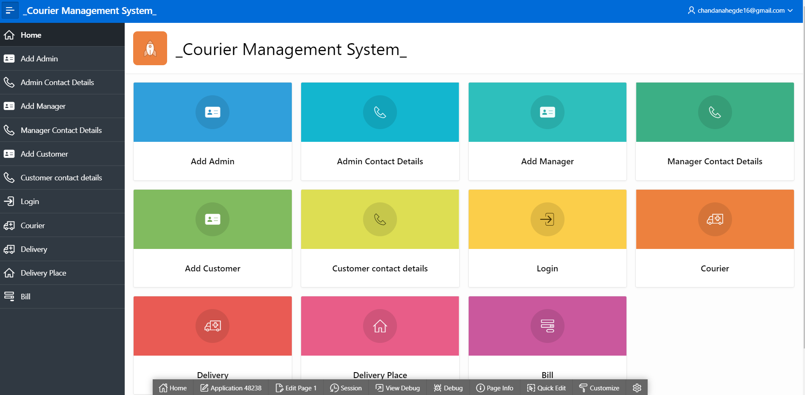

**Add Admin:**

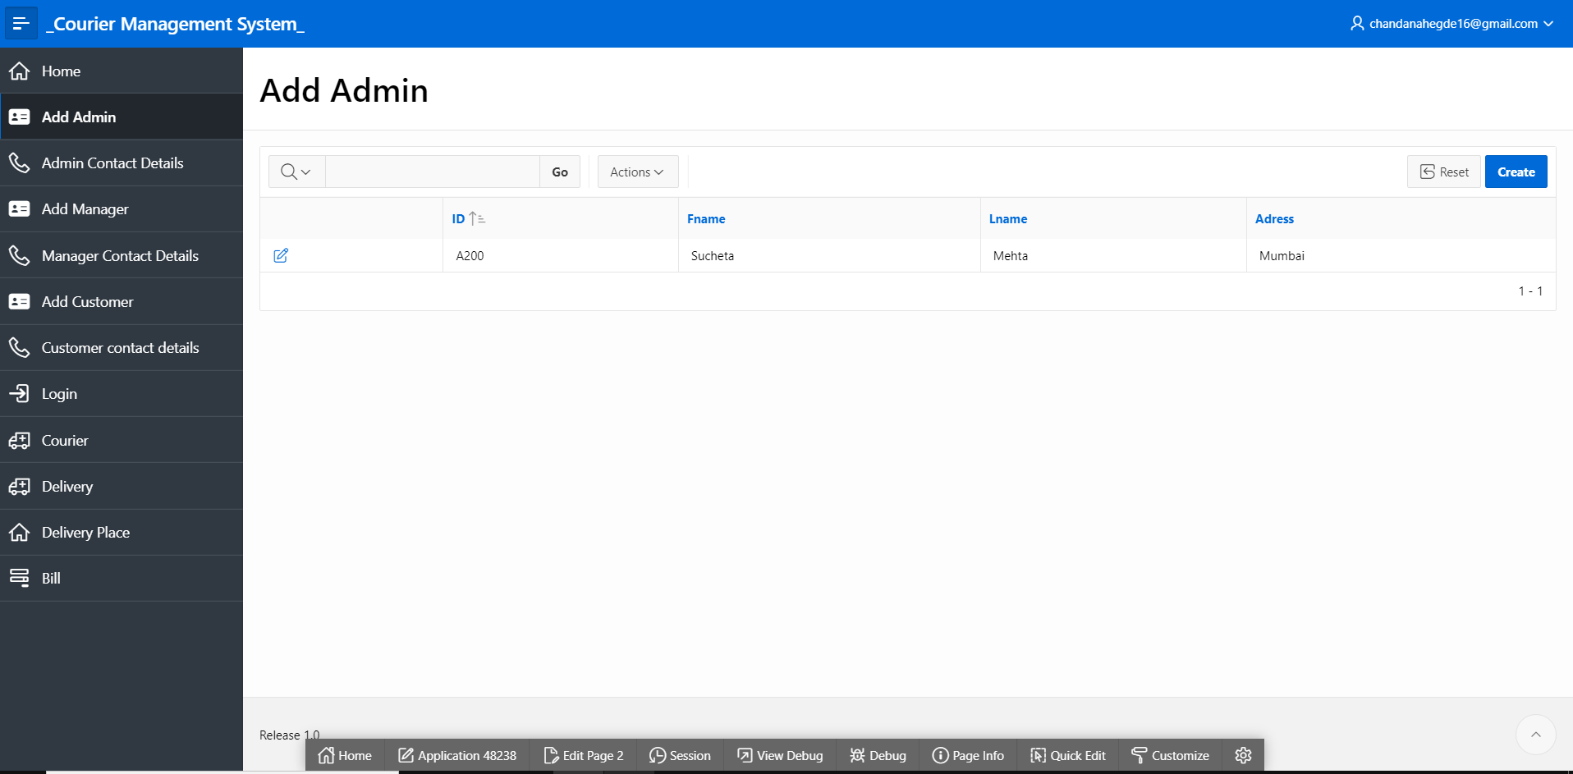

**Admin Contact Details:**

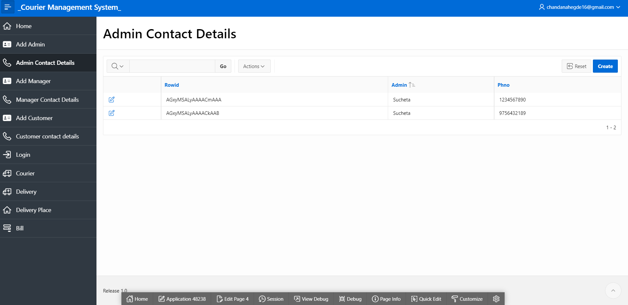

**Add Manager:**

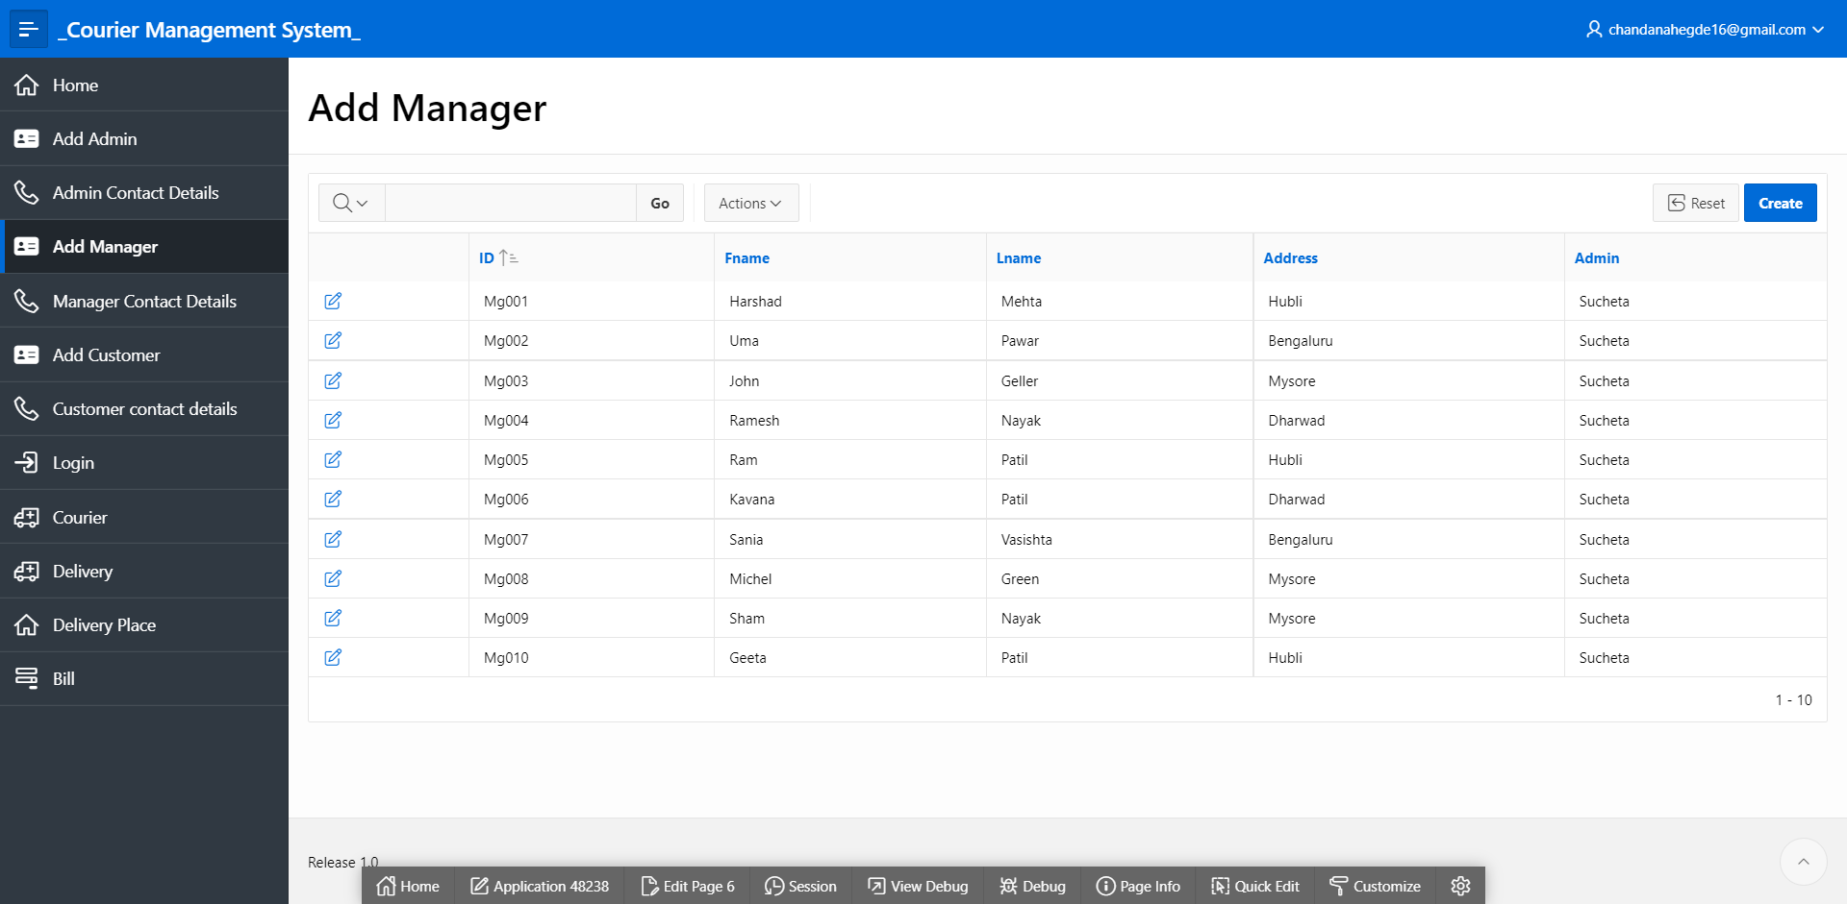

**Manager Contact Details:**

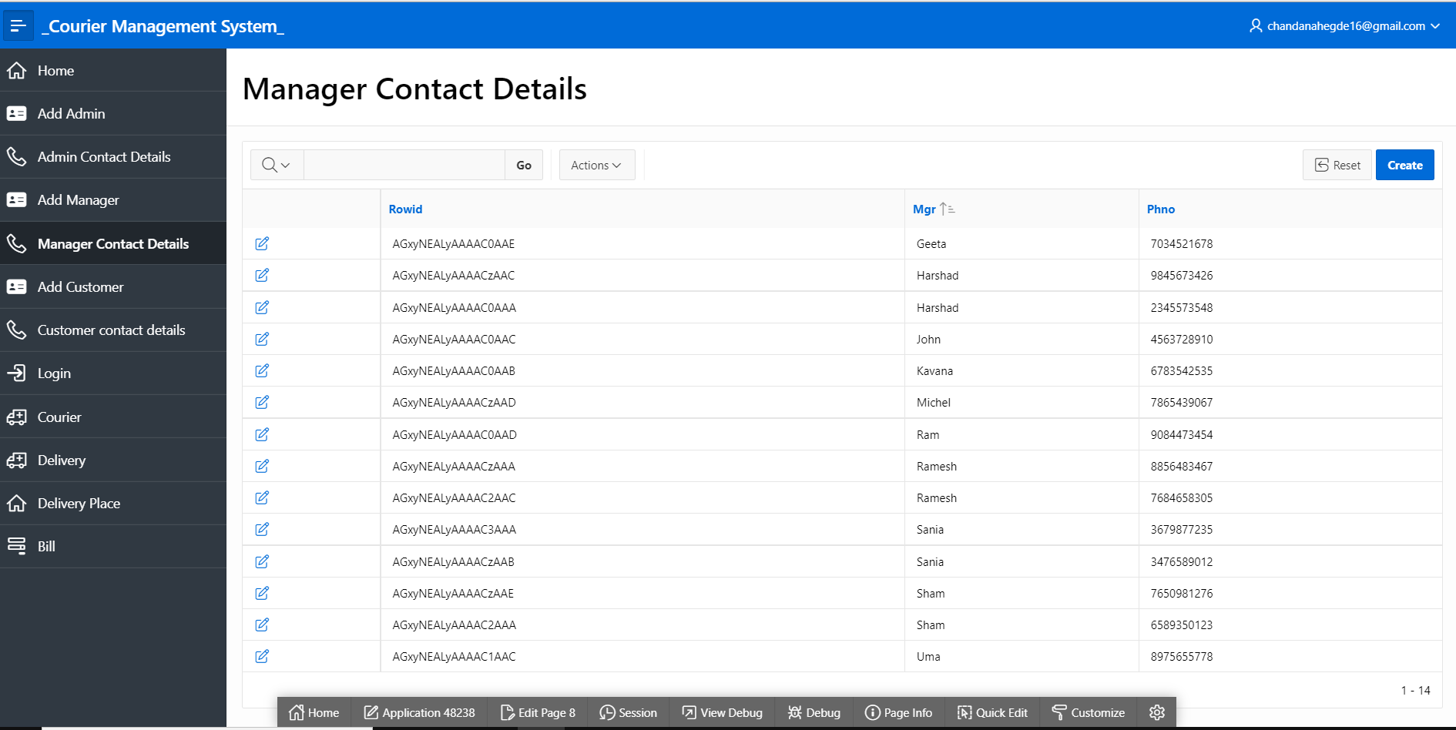

**Add Customer:**

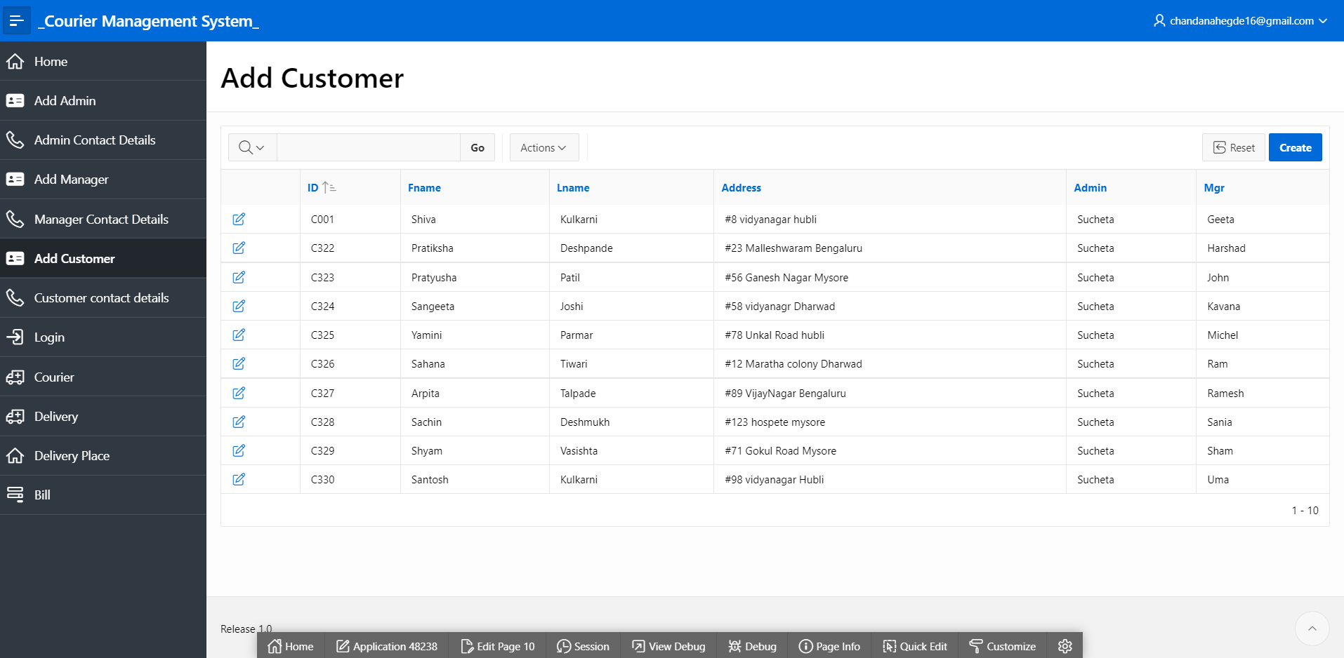

**Customer Contact Details:**

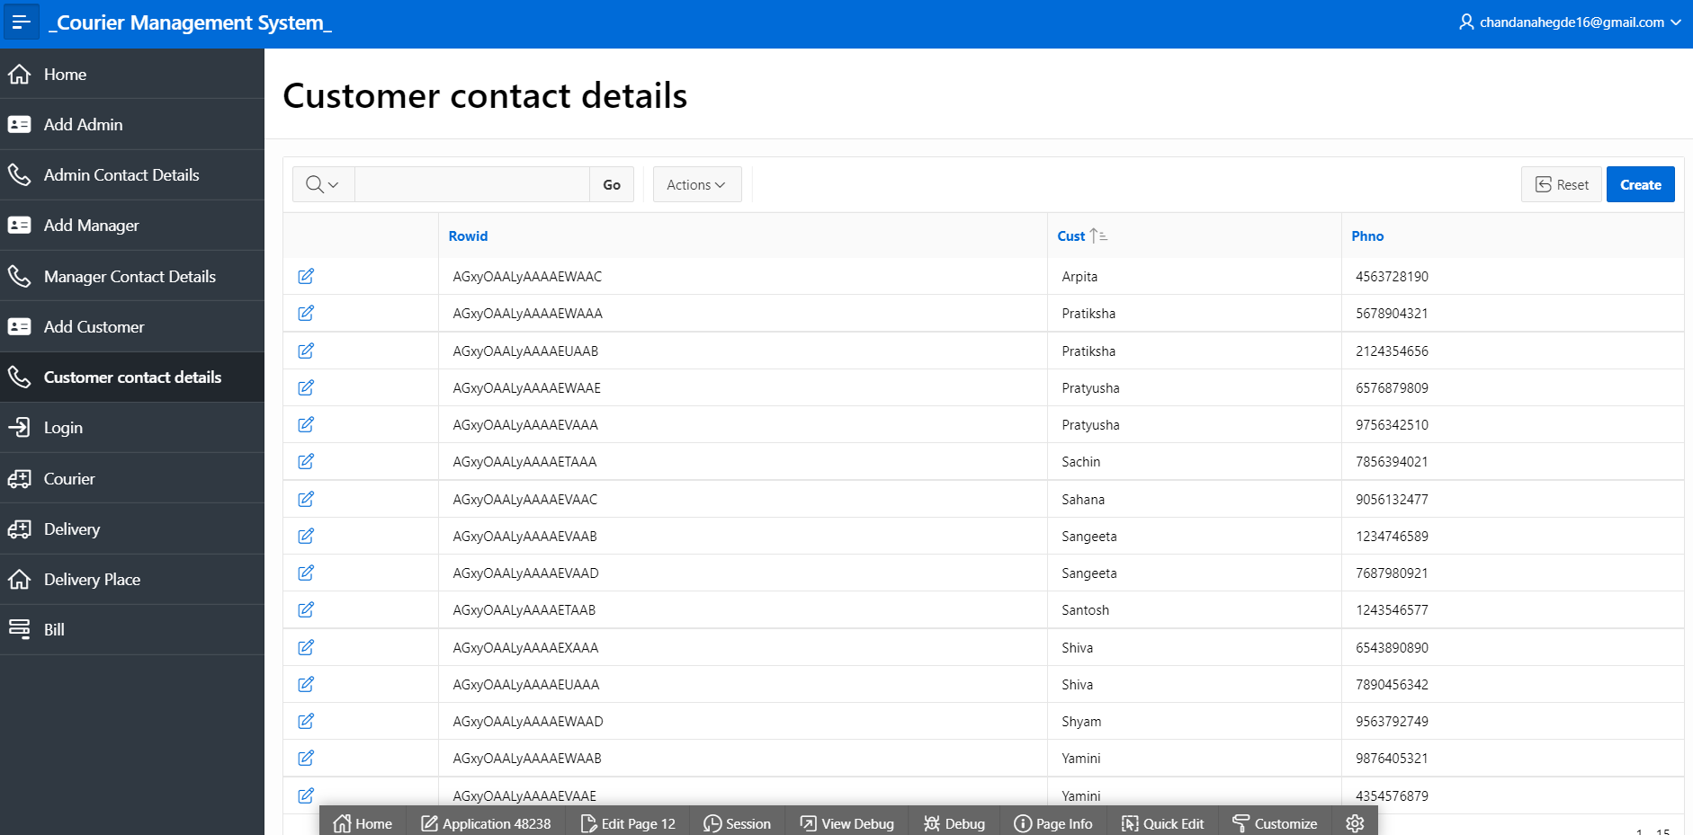

**Login:**

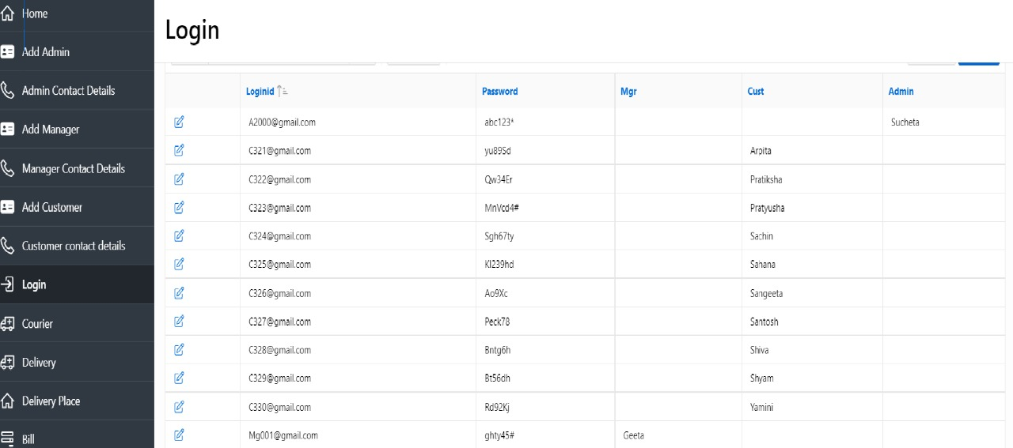

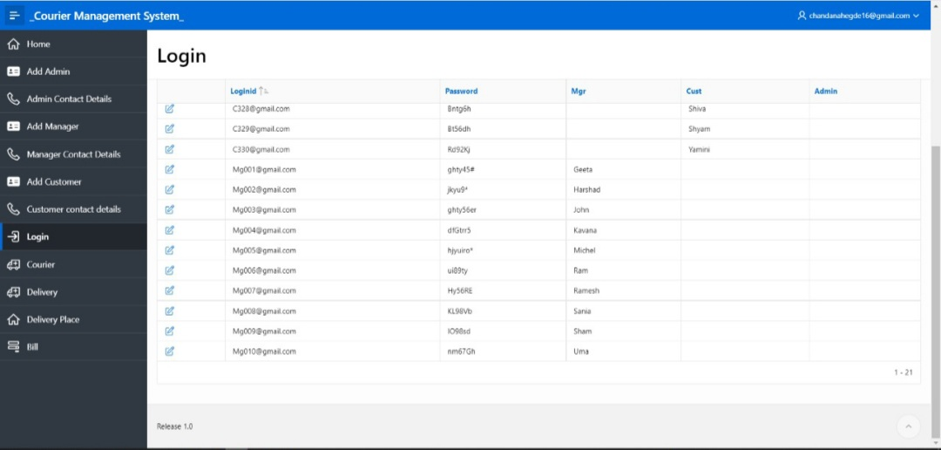

**Courier:**

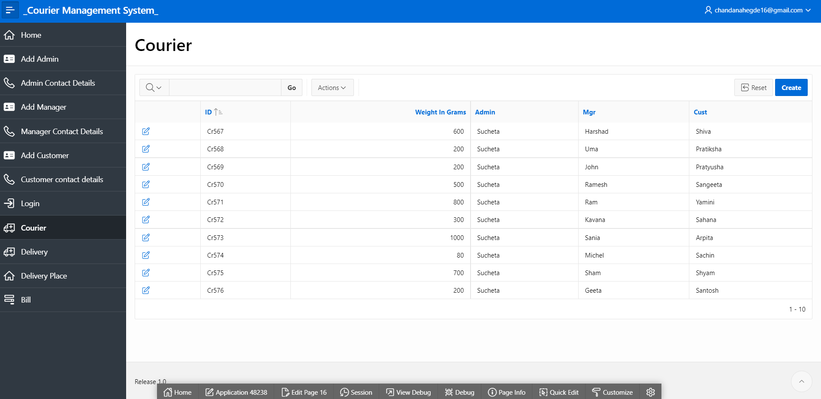

**Delivery:**

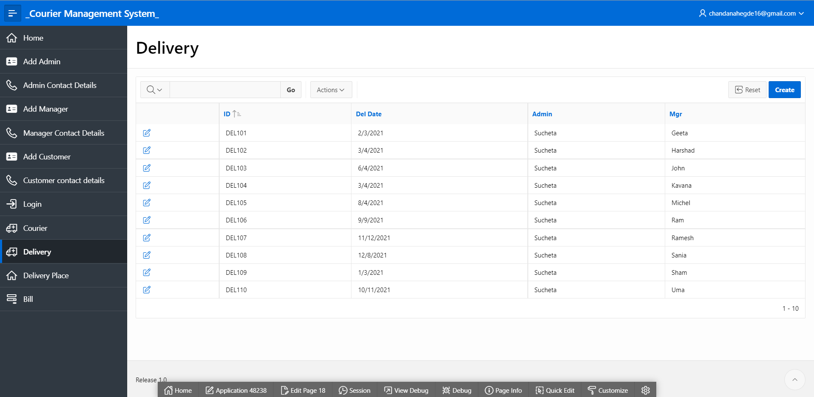

**Delivery Place:**

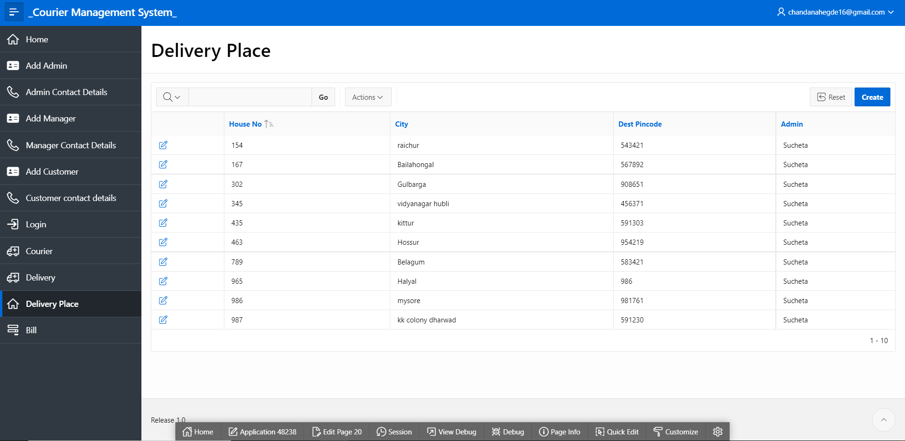

**Bill:**

